APPETIZERS ½ Pan SALADS ½ Pan Full Pan
Pretzel Nuggets $35.00 Tossed $40.00 $60.00
Served with Beer Cheese Chopped Salad $60.00 $80.00
Chicken Kabobs $70.00 Add Chicken $20.00 $30.00
Served with Rice Pilaf Caprese Salad $38.00 $70.00
Choice of Flavoring drizzle Pasta Salad $40.00 $60.00
Add Vegetables Skewers $25.00 Potato Salad $50.00 $70.00
Steak Bites Market Price Coleslaw $40.00 $60.00
Tender bites of steak deep-fried
Mini Tacos $35.00 TRAYS (Serve approx. 25 people)
Served with Homemade Salsa Charcuterie Board $18.00
Egg Rolls $60.00 Fruit Tray $26.00
Homemade Reuben, Italian Beef Fruit & Cheese Tray $45.00
Vegetable or Pork Cheese & Sausage Nibbler $55.00
Meatballs $60.00 Veggie Platter $35.00
Choice of sauce

DIPS (Serve approx. 25 people) SANDWICHES (Serve approx. 25 people)
Spinach & Artichoke Dip $50.00 Choice of meats, cheeses & breads
Served with Garlic Naan Pita Pinwheels $48.00
Buffalo Chicken Dip $45.00 Finger Sandwiches (Triangles) $34.00
Served with homemade tortilla chips Hawaiian Roll Sandwiches $62.00
Chicken Salad Croissants $48.00
BROASTED CHICKEN Fresh chicken salad served on
16 piece $18.00 mini -croissants with lettuce & tomato
32 piece $35.00
64 piece $68.00 CHICKEN WINGS
96 piece $100.00 Fresh Hand Battered Bone-In or Boneless
Served in Increments of 12 - $10.00
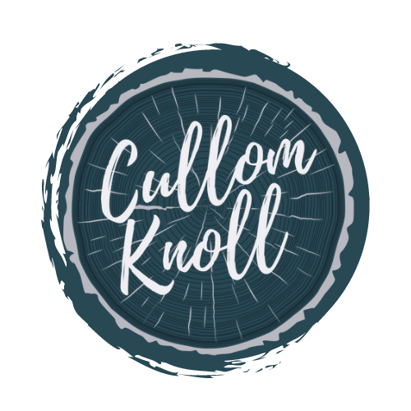
Choice of 11 Sauce Flavors
with Carrots & Celery

Main Entrees ½ Pan Full Pan
Pulled Pork $65.00 $80.00
Italian Beef $90.00 $170.00
Sausage & Peppers $60.00 $80.00
Mostaccioli $40.00 $60.00
Fettuccine Alfredo w/Chicken $60.00 $80.00

½ PAN SERVES 20-25 PEOPLE FULL PAN SERVES 45-50 PEOPLE

SIDES ½ Pan
Mashed Potatoes w/ gravy $30.00
Seasoned Potato Wedges $20.00
Homemade Macaroni & Cheese $40.00
Homemade Potato Pancakes $45.00
Includes applesauce & sour cream

*Customizable specialty menus available based on your event ~ priced per person*
Pasta Bar ~ Taco Bar ~ Pizza Buffet (20 % off the menu price)

WE OFFER DELIVERY TO YOUR OFFSITE EVENT ALSO!

LET US HELP PLAN YOUR NEXT EVENT!
BABY SHOWERS ~ BRIDAL SHOWERS ~ BIRTHDAY PARTIES

WE HAVE 2 PARTY ROOMS AVAILABLE FOR YOUR EVENT!
BACK SEMI-PRIVATE ROOM (40-45 PEOPLE)
PRIVATE UPSTAIRS ROOM (25-30 PEOPLE)

ALCOHOL PACKAGES FOR YOUR EVENT ARE AVAILABLE

